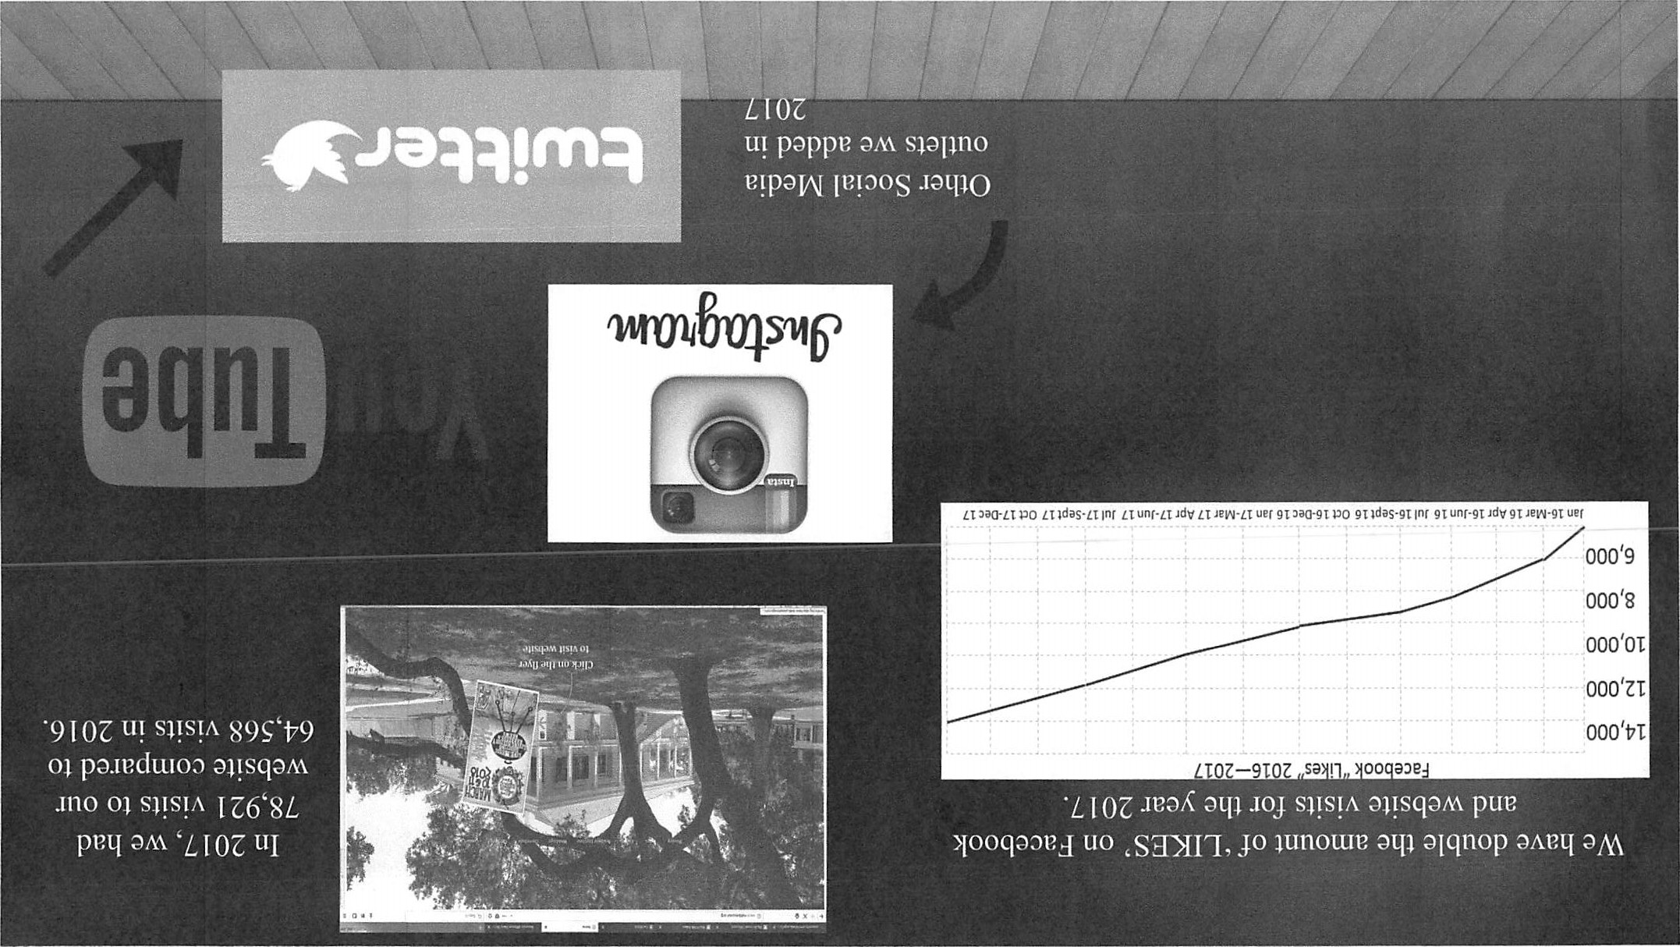

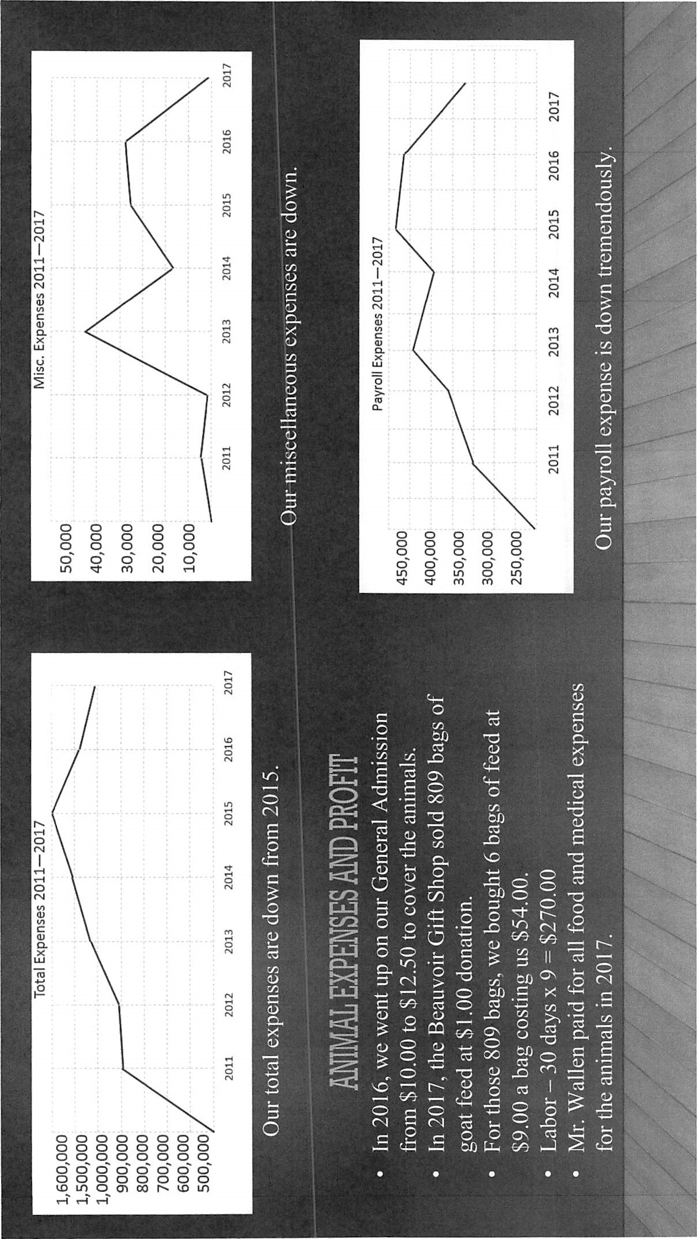
Total Fixed Assets
Other Assets
- • HANCOCK BANK ENDOWMENT  - C SCHWAB - McCain Endowment  - C SCHWAB - Beauvoir Endowment  1522 • Bricks 4 Beauvoir - Contra  1600 • Security Deposits Assets | 506,865.06  1 , 137,285.83  523,950.32  -5,000.00  50.00

Total Other Assets | 2,163,151.21

TOTAL ASSETS
LIABILITIES & EQUITY
Liabilities
Current Liabilities
Accounts Payable
2000 • Operating Accts Payable | 46,997.99
2010 • Rest/Rsv Accts Payable | -359.60

Total Accounts Payable  Credit Cards | 46,638.39
2082 Bank of America - MC 1526 | -860.75
2080 BANK OF AMERICA CREDIT CARD | -195.96

Total Credit Cards  Other Current Liabilities | -1 ,056.71
2110 • PR - Soc Security Withheld | -527,561.63
2112 • PR - Fed Income Tax Withheld | -521.00
2114 • PR - Medicare Withheld | -343.80
2120 • PR - MS Income Tax Withheld | 259.01
2122 • PR - MS Ull Tax Payable | -2,305.79
2124 • PR - MS Training Contribution | -147.43
2130 • PR - Smple IRA | -129,898.48
2131 • PR - Health Insurance | -866.77
2132 • PR - Wage Garnishments | 281.92
2200 • Sales Tax Payable -- | 1,739.12
2202 • Vehicle Tax Payable | —4,464.91
2302 • Ceremonial Burial Acct | 2,000.00
2305 • Deposits Payable | -3,000.00
2310 • Prepaid Income  319 • JDPL AIC REPAIR | 2,000.00
319-1 • Income | 12,305.00
2
ASSETS
Current Assets
CheckinglSavings
1010 • Petty Cash | 271.26
1015 • Cash - Tills & Change | 1,816.60
1030 • Operating Account | 18,808.96
1035 • Rest/Reserve Account | 7,643.43
1040 • Gardens Acct | 999.78
1045 • Construction Account | 28,459.03
1050 • Preservation Account | 582.97

Total Checking/Savings  Accounts Receivable | 58,582.03
1202 GRANTS RECEIVABLE - | 2,856.83
1200 • Accounts Receivable | 1 ,040.48
1205 • Deposits Receivable | 2,000.00

Total Accounts Receivable  Other Current  12100 ASK CPA - Inventory Asset  - • Inventory - Gift Shop  - • Sales Tax - Discounts  1415 • Undeposited Funds  1440 • Payroll - Emp Pmts Receivable  1450 • Bricks 4 Beauv Develop Fund | 5,897.31  59,971.86  129,281.82  -5,063.18  649.55  -954.00  5,000.00

Total Other Current Assets | 188,886.05

Total Current Assets  Fixed Assets | 253,365.39
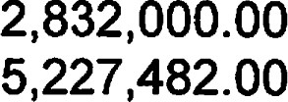
- • Beauvoir Grounds
- • Beauvoir House
- • JD PL  - • Other Bldgs & Structures  1510 • Furniture, Fixtures, Equipment  1520 • Accumulated Depreciation  1530 • Artifacts & Collections  1532 • JDPL Statue  - • Machinery & Outside Eqpt  - • Construction in Progress | 11,495,711.10  108,190.00  141,967.00  263,211.00  407,119.00  88,000.20

1
357 • FEMA PROJECTS MASTER (101-11)
357-30 • JDPL & CSM Project (11191)
357-303 • Expenses-Post J.C. Duke 80,255.90
Total 357-30 • JDPL & CSM Project (11191) 80,255.90

Total 357 FEMA PROJECTS MASTER (101-... 80,255.90

Total Other Current Liabilities -837,772.32

Total Current Liabilities  Long Term Liabilities | -792, 190.64
2205 • Tractor Note Payable | -229.75

Total Long Term Liabilities -229.75

Total Liabilities  Equity  3002 • Net Assets - Unrestricted | -792,420.39
3006 • Net Assets - Perm Restricted | 8,461 ,440.47
3050 RETAINED EARNINGS | 156,598.77
3100 • Change in Securities Value | 189,701.05
Net Income | -11,418.21

Total Equity 23,698,886.29

TOTAL LIABILITIES & EQUITY
4
319-2 • Expenses -12,305.00

Total 319 JDPL AIC REPAIR | 0.00
322 PR Liab - TO RECLASSIFY 326 • SPECIAL SAVINGS ACCT. | 9,473.06
326-1 • Income | 23,649.98
326-2 • Expenses | -23,649.98

Total 326 SPECIAL SAVINGS ACCT.  333 • Preservation Acct |  | 0.00
333-1 • Income | 204.99

Total 333 • Preservation Acct.  341 • GARDEN CLUB ACCT.(101-3) | 204.99
862 • GARDEN CLUB - Expenses | -13,644.50

Total 341 GARDEN CLUB ACCT.(101-3)  345 BEAUVOIR PRESS ACCOUNT (244-2) | -13,644.50
345-1 • Beauvoir Press Sales | -4,518.00

Total 345 • BEAUVOIR PRESS ACCOUNT (24... 4,518.00
- VARINA'S GARDEN ACCT.(102-1)
346-3 • Botanical Gardens other Income 0.97

Total 346 VARINA'S GARDEN ACCT.(102-1)  348-7 • Christmas @ Beauvoir-2012 |  | 0.97
348-7-1 • Income | -127,550.98

Total 348-7 • Christmas @ Beauvoir-2012  348-8 • Christmas @ Beauvoir-2013 | -127,550.98
348-8-1 Income | -96,860.00
348-8-3 Festival of Trees GALA | -980.00
348-8-5 X-mas Train Ride | -10,593.oo

Total 348-8 • Christmas @ Beauvoir-2013  348-9 • Christmas @ Beauvoir-2014 | -108433.00
348-9-1 • Income | -10,731.00

Total 348-9 Christmas @ Beauvoir-2014 -10,731.00
3

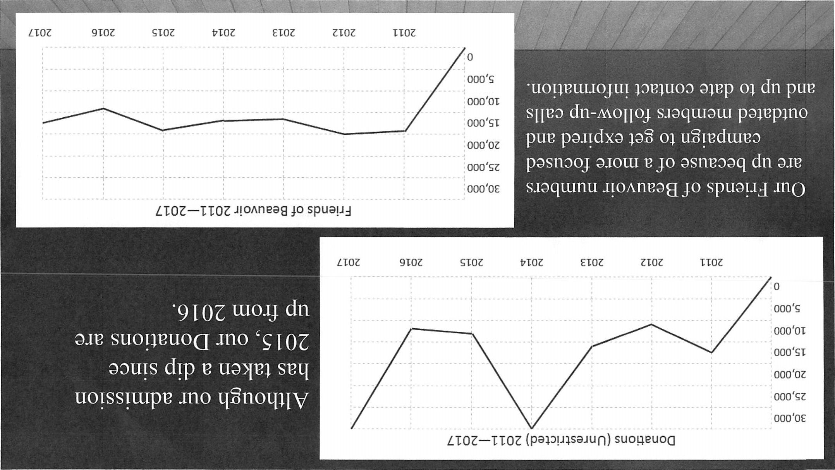

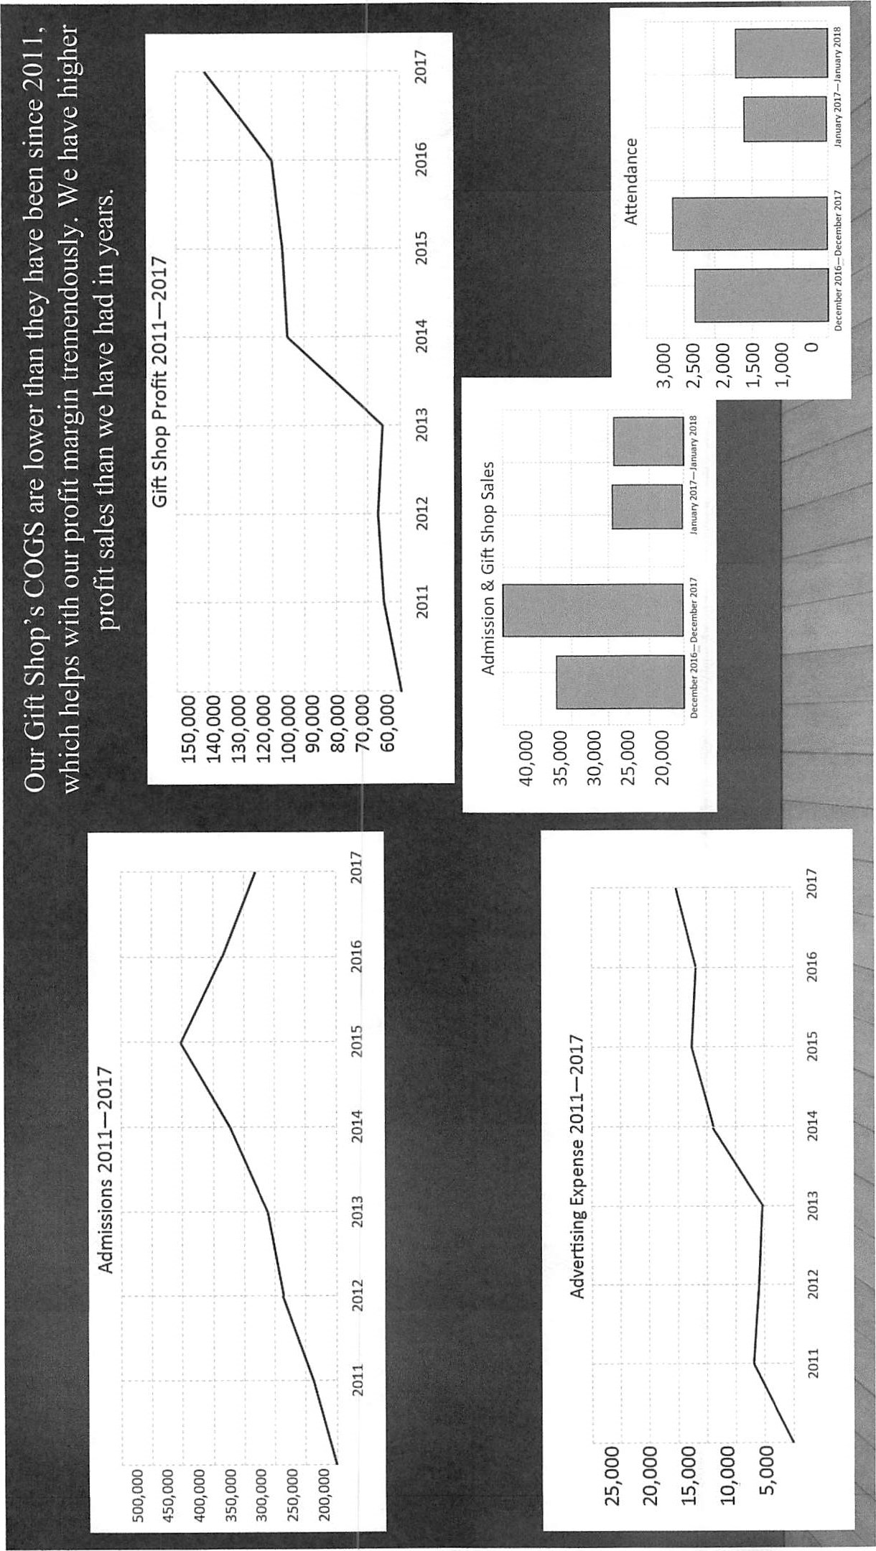

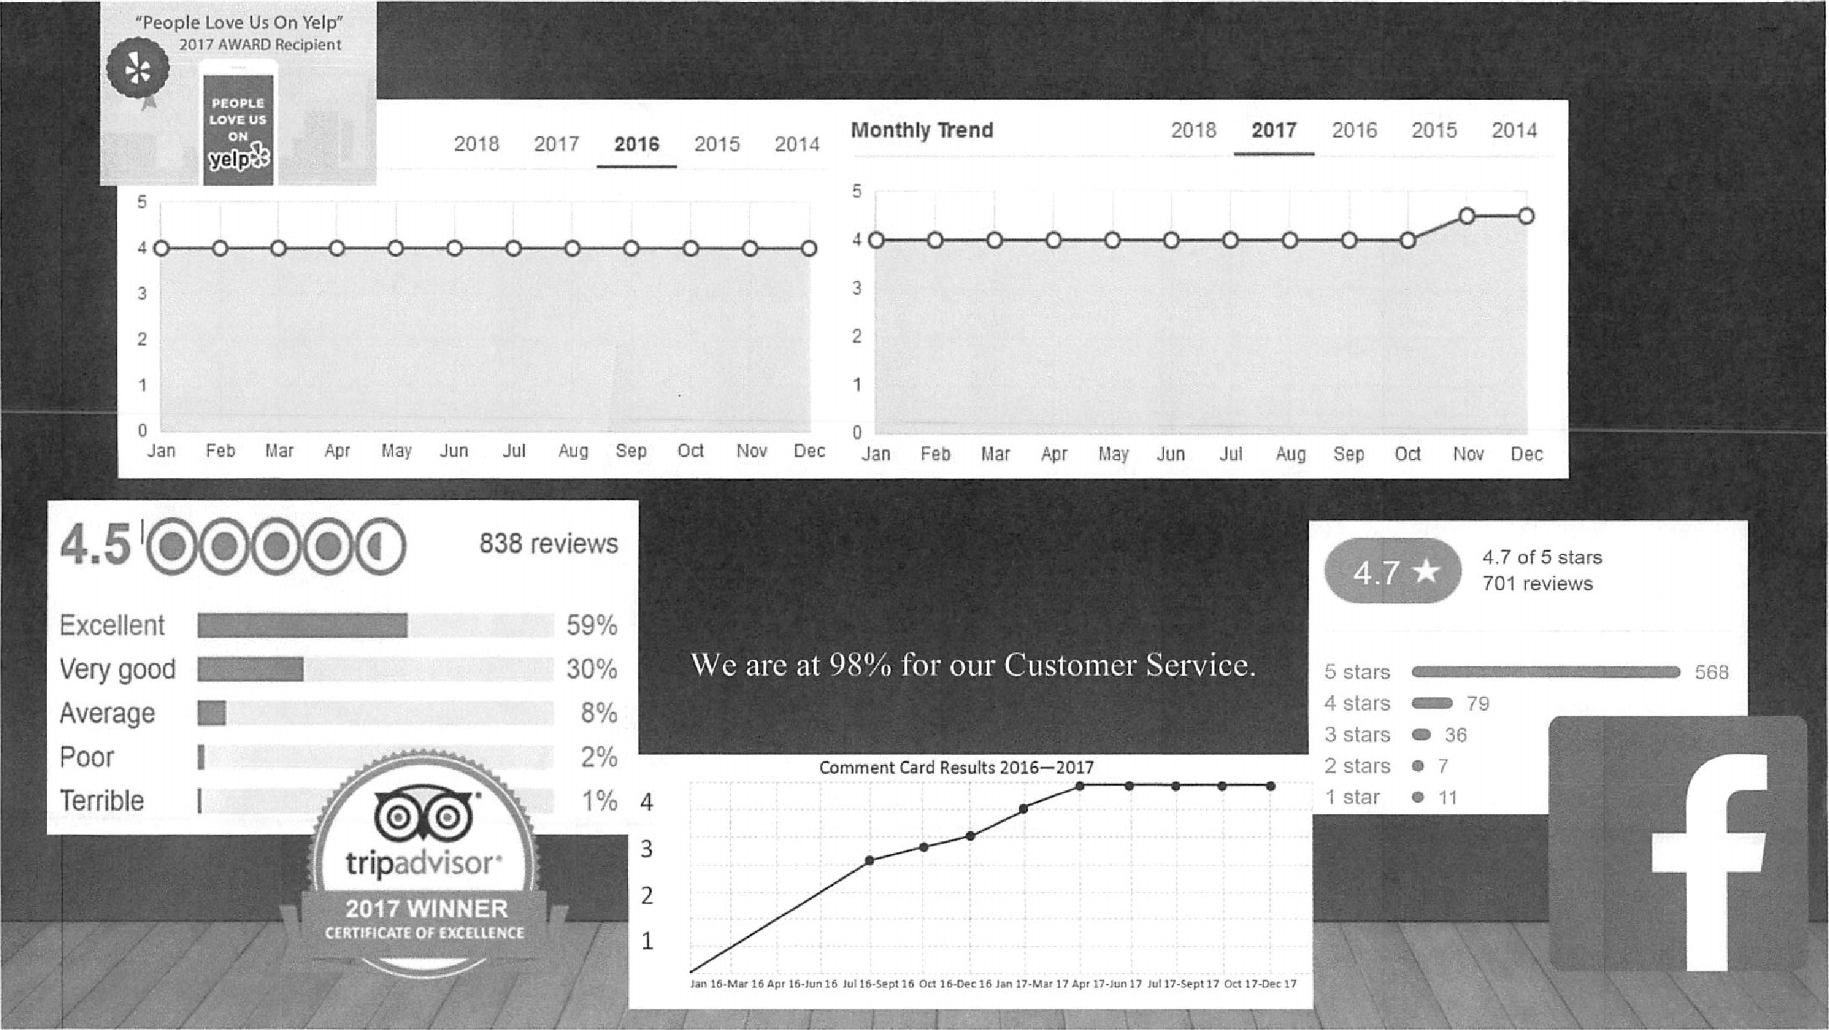

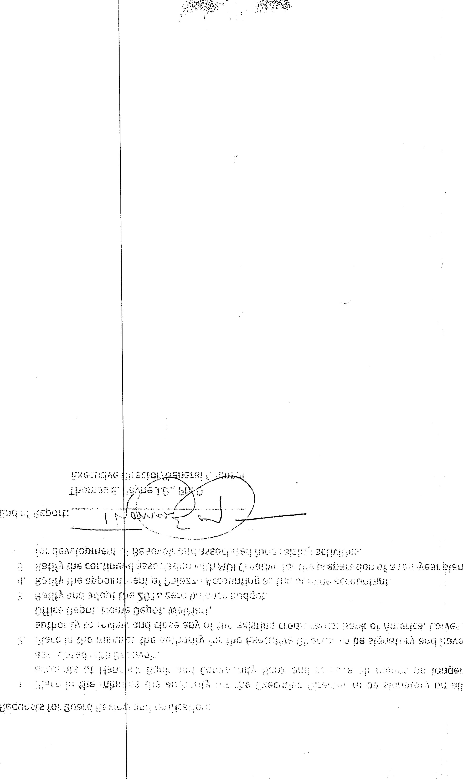
・
ま
を
Requests for Board Review and ratification:
  - . Place in the minutes the authority for the Executive Director to be signatory on all accounts at Hancock Bank and Community Bank and remove all names no longer associated with Beauvoir.
  - Place in the minutes the authority for the Executive Director to be signatory and have authority to review and close any of the existing credit cards: Bank of America, Lowes, Office Depot, Home Depot, WalMart,
  - Ratify and adopt the 2018 zero balance budget.
  - Ratify the appointment of Palazzo Accounting as the outside accountant.
  - Ratify the continued association with MDI Creative for the preparation of a ten-year plan for development of Beauvoir and associated fund raising activities.
End of Report:
Executive
Directo
Gift Shop and Mansion Services:
Ms. Rosie Boardman now has the authority and responsibility to insure cost containment in the reduction of inventory and the cost of goods sold. She has promoted the use of local vendors and branding of Beauvoir products. She has reduced the amount of inventory on hand and carefully forecasts the need for resupply, insuring efficient cash flow. The cost of goods has been reduced in 2017 from a high of 60% in past years, to under 30% this year. The Gift Shop has now initiated a new and improved Web site promoting the sale of our merchandise on the world-wide web. One of the tops sellers since last quarter has been goat feed. The Gift Shop made a profit of 145k net in 2017 the greatest net profit since 2011. Ms. Boardman has additional duties of Mansion services which includes the supervision and scheduling of all tour guides. She oversees the training of new and volunteer tour guides and has the responsibility of insuring that the Mansion is well cleaned and is kept in optimum condition for our guests.

Director of Security
Since January 3, 2017 the responsibilities of the Director of Security have been turned over to the Executive Director. After review of existing security and conducting a security assessment it was found that Beauvoir had very little existing security programs in place. The employees that were hired as night security had no training in security and were used as maintenance rather than security. Based on the risk assessment we began a program of key control, installed eleven new video cameras, and hired two new security personnel with prior experience and training in security and law enforcement. We instituted a campus wide radio system with all employees connected by both cell phone and two-way radio. One staff member is assigned to act as dispatch and will be the initial contact for public safety and first responders The dispatch staff member maintains contact with all staff members throughout the day and maintains a radio log for both security and administrative uses. Due to the increased risk now associated with the national media coverage relating to confederate statutes we have increased the presence of our security to weekend shifts. Our two security guards work ten hour shifts four days on three days off on a rotating basis which covers a Saturday and Sunday shift from 8:00 a.m. to 6:00 p.m. The security of Beauvoir is enhanced by the use of maintenance personnel in an observe and report role. All staff at Beauvoir are incorporated into the security team and we have two employees who live on property and are prepared to respond to any emergency. In addition, most of the staff have completed a four-hour training course in security and safety.

Business Development and Events
Since the last quarterly report the department is still achieving significant results. In addition to tours the department insures that Beauvoir is kept in the public eye by a robust marketing campaign that uses social media, push cards, public interviews, magazine articles and in the last year a Beauvoir commercial specially produced to enhance marketing. All at a fraction of cost using innovative marketing techniques taking advantage of free advertising space and local public television stations. Created and enhanced the Beauvoir Institute and the Ambassador program. Having already completed two well attended lectures presented by the Beauvoir Institute and creating a living history caste who plays out historical vignettes every third Saturday. The lecture series and living history educational vignettes have driven up our admission numbers. Our guests have indicated that they like the way we have added these experiences scoring Beauvoir with a 98% approval rating in 2017. We were awarded the Trip Advisor certificate of excellence and the Yelp award in 2017 with a rating of 4.7 out of 5. This percentage is greater than in 2016. Admissions have steadily declined beginning in 2015. From 2011-2015 admissions climbed every year. Based on admission figures from Nov.-January 2017 compared to Nov-January 2018 our admissions numbers are up by 11.9%:6207 in 2016-17 and 7052 in 2017-2018. Gift shop sales are up for the same time frame from $34106.00 in 2016-17 up 26.3% to $46,305.00. A total combined increase of 17.2 ⁰/0.

Museum Services
Since the last quarterly report, Director Peterson, has accomplished a great deal in maintaining the Museum and its artifacts. The most significant of which was continuing the reorganization and inventorying the vault and research room. This area had suffered from several years of neglect and without full time attention had deteriorated to such a condition that the very security of our archival documents and artifacts were in question. Jay has now hired full time librarian who has assisted in putting the Beauvoir Library back to its professional state. Bobby Sue Sargent previously logged more than 400 volunteer hours in the library. She has a B.S. in History and is well versed in library science. Utilizing the skills of the new librarian Jay Peterson has catalogued and inventoried over sixty per cent of the artifacts in the Vault. This has been an ongoing program over the past year and should be concluded by May, 2018. This is will be the first comprehensive inventory of the Vault since Hurricane Katrina. In addition to his duties in the library and museum Jay also acts as the IT coordinator for Beauvoir. His skills and expertise include film production and editing. He has taken a film of living history actors from our cemetery tales activity and produced a film capable of digitizing for replay in the cemetery over a smart phone. We hope to launch that application in early 2018. Jay has produced and provided lectures for the Beauvoir Institute greatly enhancing the publics access to the benefits of the Presidential Library.
- .読;ドく← .い :しレ← :ゴハ
い!
”リ~し・・はい
い纛旅0い
:し
ま「れ
、ま
:ハ
dmissions have steadily declined beginning in 2015. From 2011-2015 admissions very year. Based on admission figures from Nov.-January 2017 compared to Nov-January 2018 our admissions numbers are up by 11.9%:6207 in 2016-17 and 7052 in 2017-2018. Gift shop sales are up for the same time frame from $34106.00 in 2016-17 up 26.3% to $46,305.00. A total combined increase of 17.2 ⁰/0.
8. We have created and presented to the Board a ten- year development plan for Beauvoir which includes the plan for a nature center and bird sanctuary.
I have summarized the current organizational units and their contribution to our overall mission this first quarter:

Finance and Human Resources
Since November, 2017, the position of Director of Finance and Human Resources has been eliminated and the duties of Finance and Human Resources separated. The Executive Director will oversee all Human Resources function. An outside accounting firm will handle all financial duties. A 2018 budget has been prepared and presented to the Board for approval. The Board has authorized changing to a full year Jan-December fiscal year beginning in 2018. As a result Beauvoir has cut costs and improved efficiency.
Maintenance and Facilities
The Director of maintenance and facilities position at Beauvoir has been un-filled for several years. In June of 2017 Harry Reichner was promoted to Director of Maintenance and Facilities. A long-term employee of Beauvoir maintenance team, Harry, is responsible for the upkeep and maintenance of the entire property which includes both buildings and grounds. The Director acts as the supervisor of the maintenance crew on a day to day basis. Beauvoir has placed air conditioning in the Mansion and created a viable cyclical maintenance plan for Varina's garden. We have cleaned the entire outside of the JDPL building and have begun preparation to paint the mansion. The maintenance crew has painted and revitalized the Beauvoir room and other parts of the JDPL when weather forces them inside. We have planted more than seventy live oak trees with a grant from the Forestry Department and have placed informational optical character readers to educate the guest on the type and history of the tree. Beauvoir hopes to have a class two arboretum designation by October of 2018. We have created and presented to the Board a ten- year development plan for Beauvoir which includes the plan for a nature center and bird sanctuary. We have an active marketing campaign selling the whole property designed to get the repeat customer.

・ま誌↓
・:ロ剏
当0 :
、リをむ、 ← !イらら
.に
い当: 4. : .、ノこ一なノ3」こいIj、
.「声き自′
器廴-'
′ 3は亂ー
・ロ
( iいい.6
当明・
・一ミ置

い、
・・いと廴ま.

均0 :い:
「ン ,
2
Executive Director's Summary Report
First Quarter 2018
I wanted to take this opportunity to thank the Mississippi Sons of Confederate Veterans, Inc., (SCV) and the Board of Directors of Beauvoir for giving me this opportunity to serve as Executive Director. Guarding the sacred trust placed in us by Varina Davis our core mission has been to educate and commemorate the legacy of President Jefferson Davis and the Confederate veteran. January 2, 2018, marked my first anniversary as Executive Director and General Counsel. It has been a tumultuous year of Tornadoes, Hurricanes, freezing pipes and ceiling failures. But, some of our most notable accomplishments are listed below:
- A 2018 budget has been prepared and presented to the Board for approval. The Board has authorized changing to a full year Jan-December fiscal year beginning in 2018. As a result Beauvoir has cut costs, improved efficiency, and increased profits.
- Beauvoir has placed air conditioning in the Mansion and created a viable cyclical maintenance plan for Varina's garden. We have cleaned the entire outside of the JDPL building for the first time since it was built. Painted the entire front fence, removed obstructed fencing on the grounds, and cleaned up the barn and surrounding area. Made three capital equipment purchases, lawn mower, tractor and six passenger golf cart. Planted over 70 live oak trees which will result in Beauvoir becoming a class two arboretum by October of 2018. We were able to maintain the good condition of the property despite a tornado and Hurricane, closing the property for only three days. Containing costs remaining within our budget for most of the year with the infusion of only $65,000.00 in reserve funds; the lowest infusion of funds required in the last five years.
- The Gift Shop made a profit of 145k net in 2017 the greatest net profit since 2011.
- In 2017 and continuing Beauvoir has had more un-restricted donations and increases in both our grants received and our Friends of Beauvoir account.
- Created and enhanced the Beauvoir Institute and the Ambassador program. Having completed two well attended lectures presented by the Beauvoir Institute and creating a living history caste who plays out historical vignettes every third Saturday. The lecture series and living history educational vignettes have driven up our admission numbers.
- Our guests have indicated that they like the changes we have made in their experiences scoring Beauvoir with a 98% approval rating in 2017. We were awarded the Trip Advisor certificate of excellence and the Yelp award in 2017 with a rating of
4.7 out of 5. This percentage is greater than in 2016.
cTÏeueferson La's 'fome fres£Tent£cfZ£brary
EXECUTIVE DIRECTOR'S REPORT TO THE BOARD OF DIRECTORS
OF
THE MISSISSIPPI SON'S OF CONFEDERATE VETERANS, INC.
BEAUVOIR
Prepared by:
Thomas E. Payne, J.D., Ph.D.
Executive Director/General Counsel
February 10, 2018

